SOFTWARE PROJECT MANAGEMENT (Change Management)
ANANT MISHRA (E23CSEU0324)
BATCH-11

1.Project Summary
This includes all important key points of projects and detailed structure of project for better work flow and tracking.
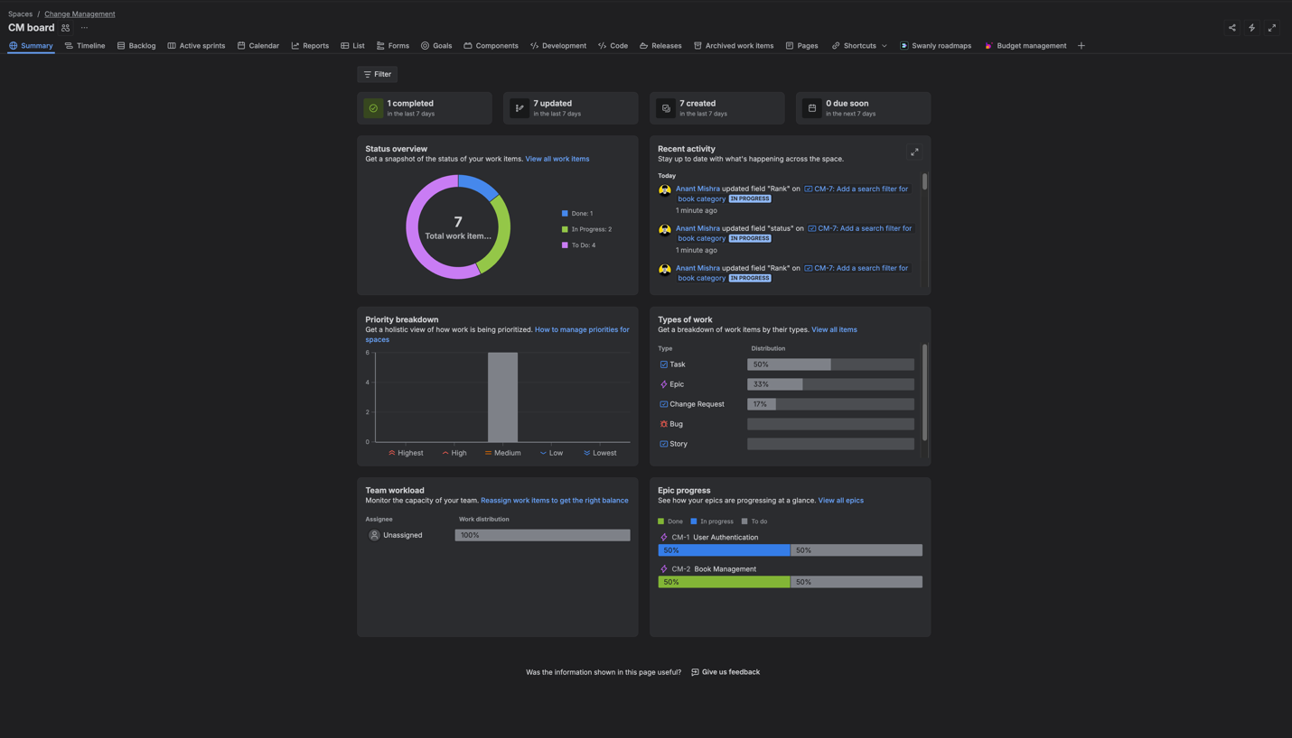

2. Timeline
This panel shows proper timeline updates of the project , when was task done and how it proceeded.

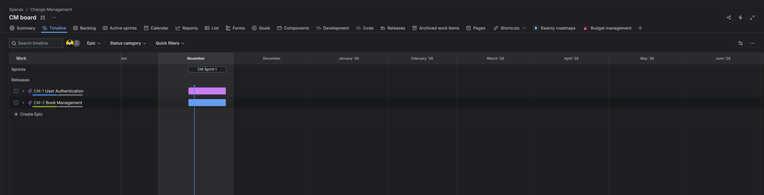

3.Backlog
In Jira, a backlog is the list of all issues, tasks, or stories that are planned but not yet started. It acts as a holding area where work items are organized and prioritized, so teams can decide what to work on next. In Scrum, items from the backlog are moved into sprints during planning, while in Kanban, tasks are picked directly from the backlog. In short, the backlog is like a team’s to-do list for future work.

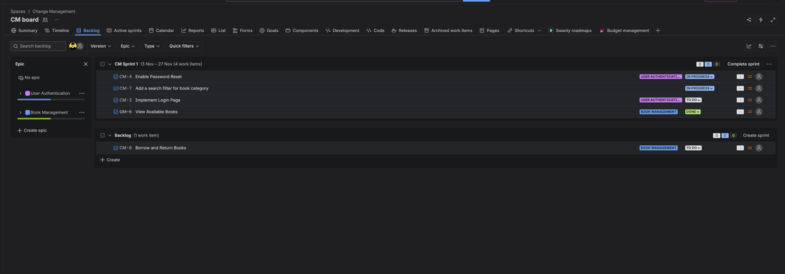

4. New Issue Type
In jira, we can easily add issue types. In this case related to project we have created Change Request.

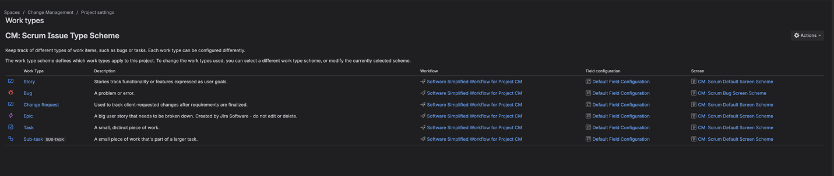

4. Comments and History of Issue
In jira, we can check for comments and History of Issue for better communication and coordination between added team and proper logs tracking.
